If you have 3 Easter Eggs and you find 3 more, how many Easter Eggs will you have altogether?

If you have 4 teddies and you buy 2 more, how many will you have altogether?

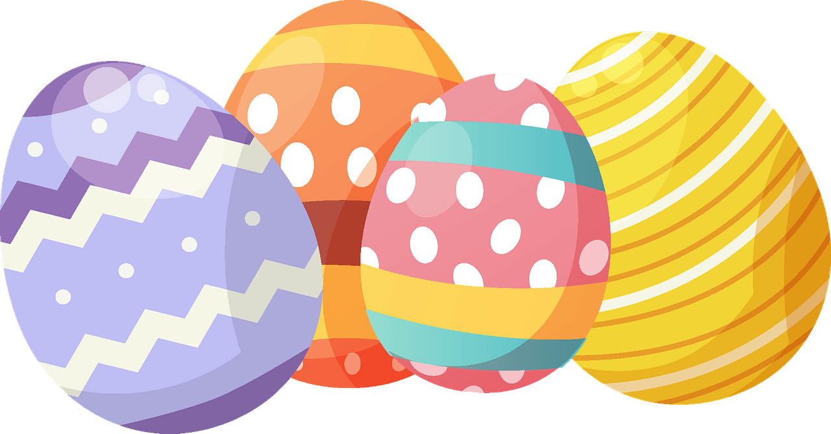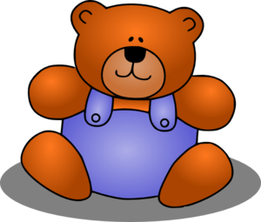

If there are 7 cupcakes and you eat 2 of them, how many cupcakes will be left?

If you have 4 sweets and you give 2 to your friend, how many sweets do you have left?

If you have 5 cookies and you bake 3 more, how many cookies would there be altogether?



If there were 6 people on a bus and 3 got off, how many people would be left on the bus?

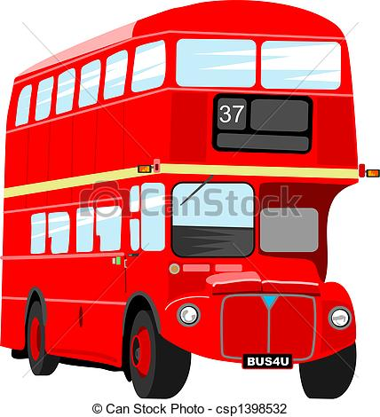

If you pick 8 flowers and give 2 to your Mum, how many do you have left?



If you eat 4 slices of pizza and your Brother eats 2 slices of pizza, how many slices have you eaten altogether?

